LAB ASSIGNMENT 2

T1

<!DOCTYPE html>

<html lang="en">

<head>

<meta charset="UTF-8">

<meta name="viewport" content="width=device-width, initial-scale=1.0">

<title>About Me</title>

<style>

body {

font-family: Arial, sans-serif;

max-width: 800px;

margin: 0 auto;

padding: 20px;

}

h1, h2, h3 {

color: #333;

}

p {

line-height: 1.5;

color: #666;

}

</style>

</head>

<body>

<header>

<h1>About Me</h1>

</header>

<section>

<h2>Introduction</h2>

<p>

Hello! My name is Sarthak Raj, I am a 2nd year BTech student pursuing my degree from RGIPT in the information technology branch.

</p>

</section>

<section>

<h3>My Skills </h3>

<p>

I am developing my skills in the field of web technology Currently i am learning about HTML CSS and Javascript

</p>

</section>

<section>

<h2>Interests</h2>

<p>

I have a deep interest in Travelling. I love to explore different cultures and thier customs, I am also love to explore about space by reading different articles I find joy in diverse experiences that enrich my life.

</p>

</section>

</body>

</html>



T2

<!DOCTYPE html>

<html lang="en">

<head>

<meta charset="UTF-8">

<meta name="viewport" content="width=device-width, initial-scale=1.0">

<title>Image Description</title>

<style>

body {

font-family: Arial, sans-serif;

max-width: 800px;

margin: 0 auto;

padding: 20px;

}

h1 {

color: #333;

}

p {

line-height: 1.5;

color: #666;

}

img {

max-width: 100%;

height: auto;

display: block;

margin: 20px 0;

}

</style>

</head>

<body>

<header>

<h1>Exploring Nature's Beauty</h1>

</header>

<section>

<img src="C:\Users\rajsa\OneDrive\Desktop\your-image.jpeg" alt="Nature Image" width="600" height="400">

<p>

This breathtaking image captures a serene moment in nature. The vibrant colors of the sunset reflect off the calm water, creating a mesmerizing scene. The silhouette of the trees adds a touch of tranquility to the overall composition, inviting viewers to pause and appreciate the beauty of the natural world.

</p>

</section>

</body>

</html>

Output

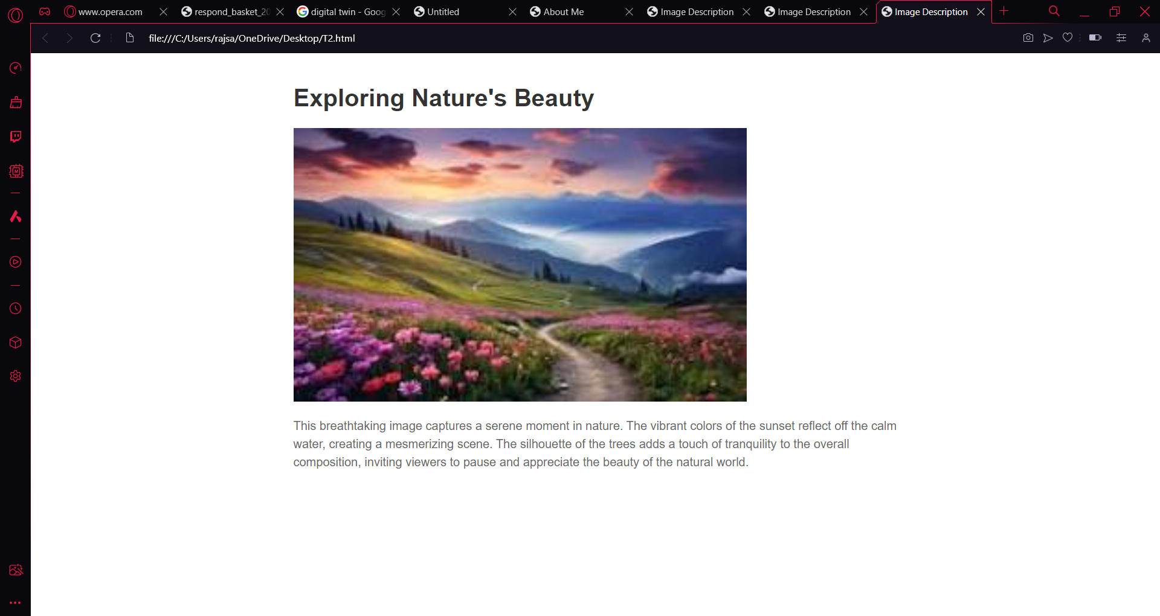

T11

<!DOCTYPE html>

<html lang="en">

<head>

<meta charset="UTF-8">

<meta name="viewport" content="width=device-width, initial-scale=1.0">

<title>Search Engine Link</title>

<style>

body {

font-family: Arial, sans-serif;

text-align: center;

max-width: 800px;

margin: 0 auto;

padding: 20px;

}

h1 {

color: #333;

}

img {

cursor: pointer;

max-width: 100%;

height: auto;

display: block;

margin: 20px auto;

}

</style>

</head>

<body>

<header>

<h1>Click the Image to Search</h1>

</header>

<section>

<a href="https://www.google.com" target="_blank">

<img src="C:\Users\rajsa\OneDrive\Desktop\your-image.jpeg" alt="Search Icon">

</a>

</section>

</body>

</html>

Output

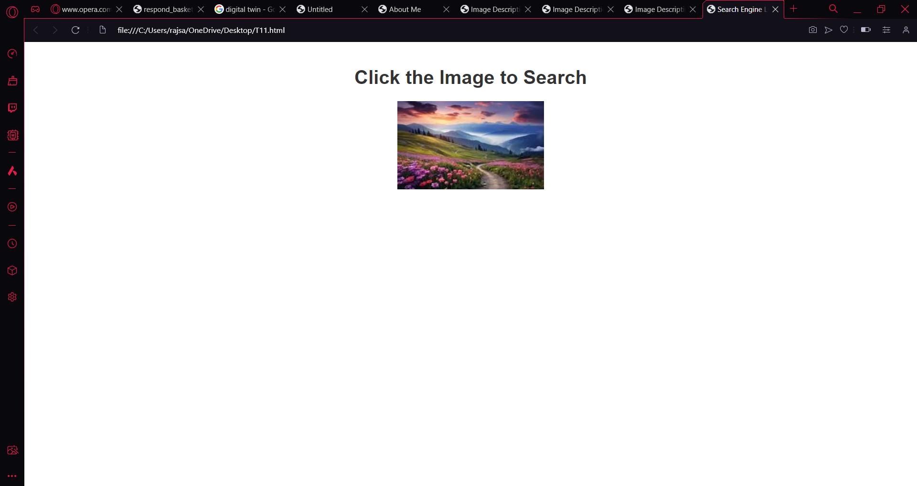

T10

<!DOCTYPE html>

<html lang="en">

<head>

<meta charset="UTF-8">

<meta name="viewport" content="width=device-width, initial-scale=1.0">

<title>Image Gallery</title>

<style>

body {

font-family: Arial, sans-serif;

text-align: center;

max-width: 800px;

margin: 0 auto;

padding: 20px;

}

h1 {

color: #333;

}

img {

max-width: 100%;

height: auto;

display: block;

margin: 20px auto;

}

p {

line-height: 1.5;

color: #666;

}

</style>

</head>

<body>

<header>

<h1>Image Gallery</h1>

</header>

<section>

<img src="C:\Users\rajsa\OneDrive\Desktop\sunset.jpeg" alt="Image 1">

<p>A Beautiful sunset </p>

<br>

<img src="C:\Users\rajsa\OneDrive\Desktop\Stars.jpeg" alt="Image 2">

<p>A Beautiful sky</p>

<br>

<img src= "C:\Users\rajsa\OneDrive\Desktop\beach.jpeg" alt="Image 3">

<p>A Beautiful beach </p>

<br>

<img src="C:\Users\rajsa\OneDrive\Desktop\hill station.jpeg" alt="Image 4">

<p>A Beautiful hill station</p>

<br>

<img src="C:\Users\rajsa\OneDrive\Desktop\waterfall.jpeg" alt="Image 5">

<p>A Beautiful waterfall</p>

</section>

</body>

</html>

Output

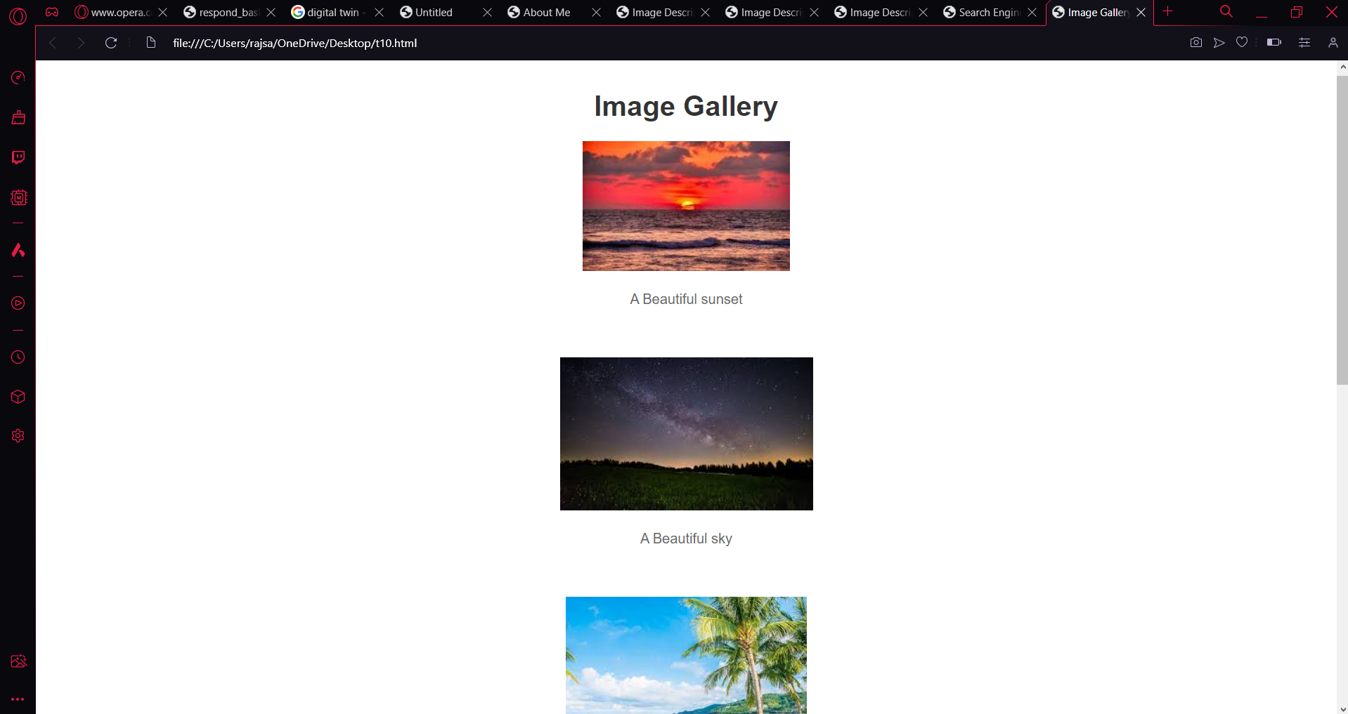

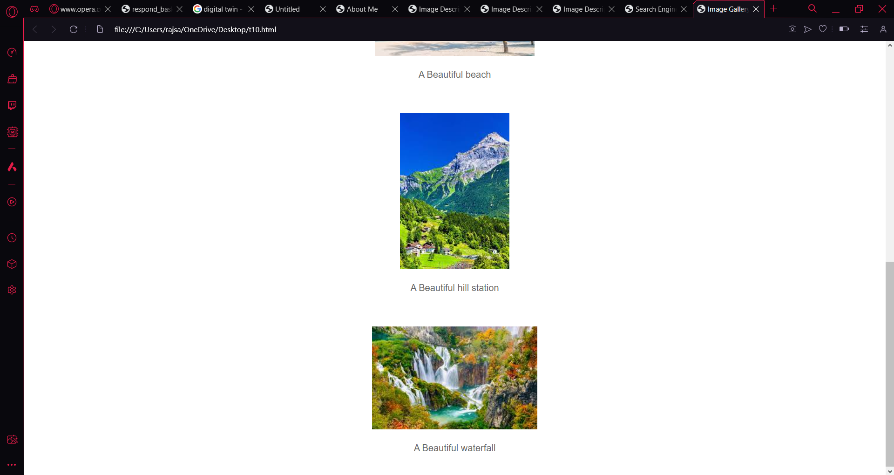

T9

<!DOCTYPE html>

<html lang="en">

<head>

<meta charset="UTF-8">

<meta name="viewport" content="width=device-width, initial-scale=1.0">

<title>Image with Border</title>

<style>

body {

font-family: Arial, sans-serif;

text-align: center;

max-width: 800px;

margin: 0 auto;

padding: 20px;

}

h1 {

color: #333;

}

img {

border: 2px solid #333;

width: 200px;

height: 200px;

display: block;

margin: 20px auto;

}

</style>

</head>

<body>

<header>

<h1>Image with Border</h1>

</header>

<section>

<img src="C:\Users\rajsa\OneDrive\Desktop\hill station.jpeg" alt="Bordered Image">

</section>

</body>

</html>

Output

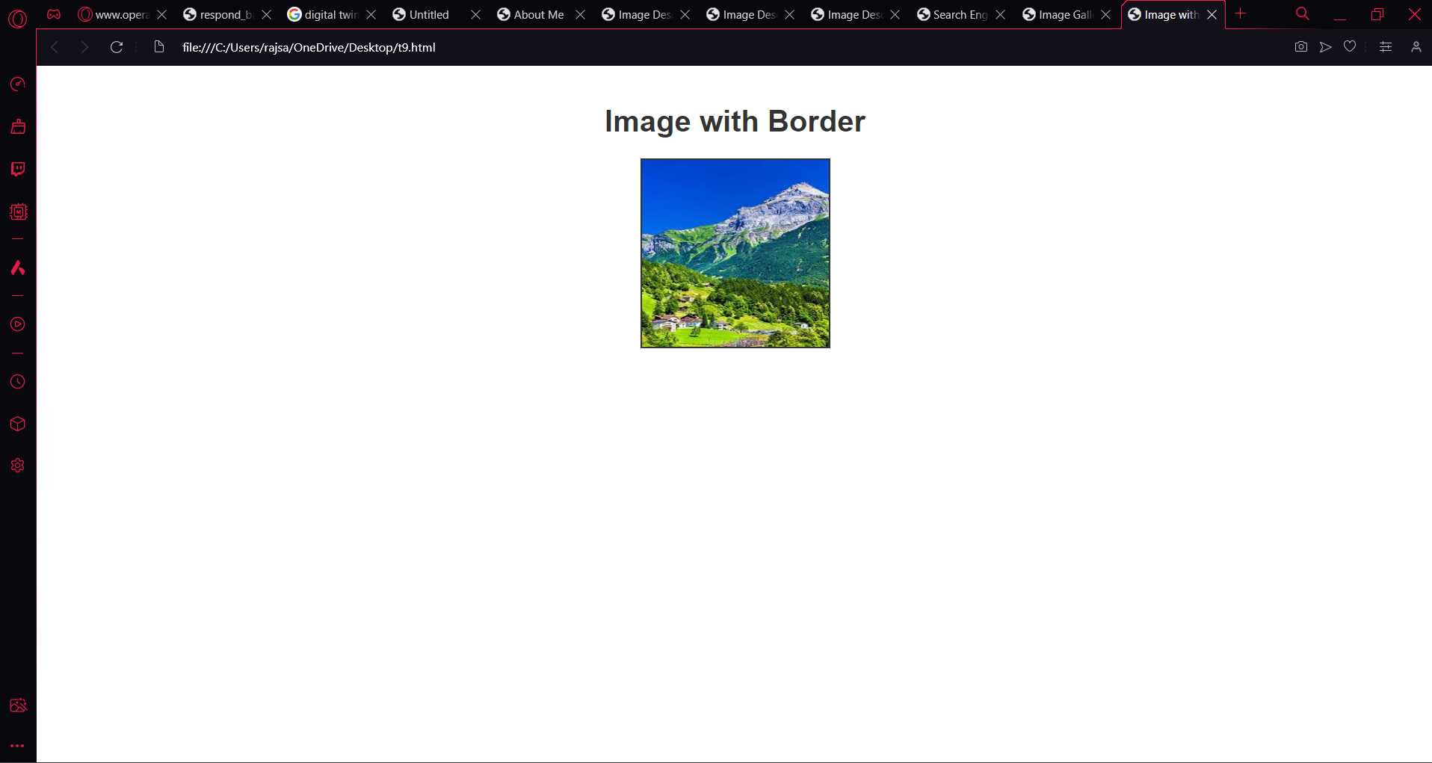

T8

<!DOCTYPE html>

<html lang="en">

<head>

<meta charset="UTF-8">

<meta name="viewport" content="width=device-width, initial-scale=1.0">

<title>Jump Links</title>

<style>

body {

font-family: Arial, sans-serif;

max-width: 800px;

margin: 0 auto;

padding: 20px;

}

h1, h2 {

color: #333;

}

a {

color: #0066cc;

text-decoration: none;

}

a:hover {

text-decoration: underline;

}

</style>

</head>

<body>

<header>

<h1>Jump Links Example</h1>

<p><a href="#bottom">Jump to Bottom</a></p>

</header>

<section>

<!-- Content goes here -->

<p>A hill station is a town located at a higher elevation than the nearby plain or valley. The term was used mostly in colonial Asia (particularly in India), but also in Africa (albeit rarely), for towns founded by European colonialists as refuges from the summer heat and, as Dale Kennedy observes about the Indian context, "the hill station ... was seen as an exclusive British preserve: here it was possible to render the Indian into an outsider".[1][2] In India, which has the largest number of hill stations, most are situated at an altitude of approximately 1,000 to 2,500 metres (3,300 to 8,200 ft).</p>

</section>

<footer>

<h2 id="bottom">Bottom of the Page</h2>

<p><a href="#top">Jump to Top</a></p>

</footer>

</body>

</html>

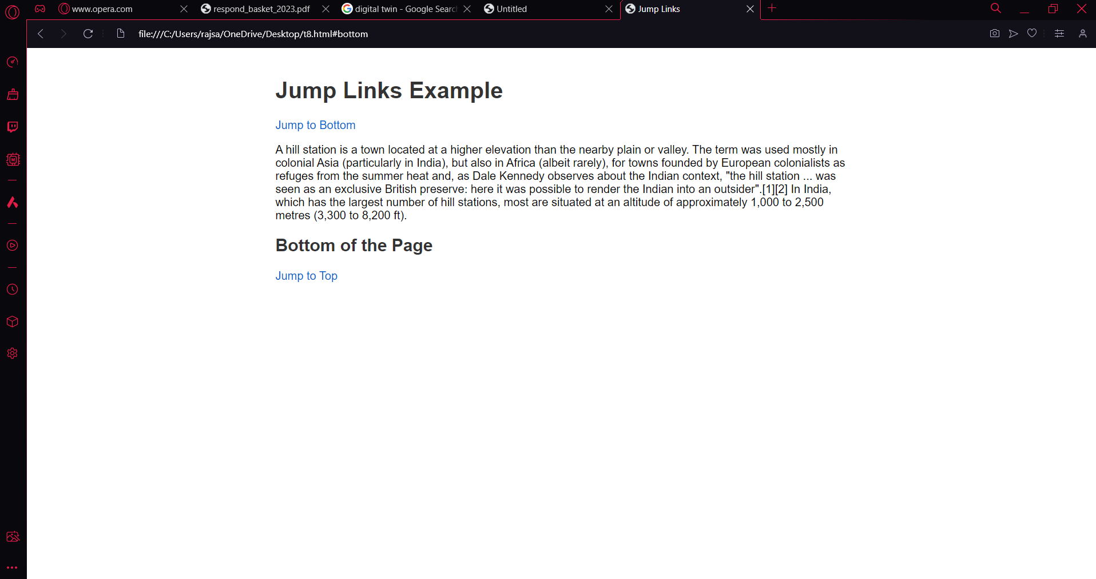

T7

<!DOCTYPE html>

<html lang="en">

<head>

<meta charset="UTF-8">

<meta name="viewport" content="width=device-width, initial-scale=1.0">

<title>Jump to Top</title>

<style>

body {

font-family: Arial, sans-serif;

max-width: 800px;

margin: 0 auto;

padding: 20px;

}

h1, h2 {

color: #333;

}

a {

color: #0066cc;

text-decoration: none;

}

a:hover {

text-decoration: underline;

}

</style>

</head>

<body>

<header>

<h1>Jump to Top Example</h1>

</header>

<section>

<p>A hill station is a town located at a higher elevation than the nearby plain or valley. The term was used mostly in colonial Asia (particularly in India), but also in Africa (albeit rarely), for towns founded by European colonialists as refuges from the summer heat and, as Dale Kennedy observes about the Indian context, "the hill station ... was seen as an exclusive British preserve: here it was possible to render the Indian into an outsider".[1][2] In India, which has the largest number of hill stations, most are situated at an altitude of approximately 1,000 to 2,500 metres (3,300 to 8,200 ft).</p>

</section>

<footer>

<h2><a href="#top">Jump to Top</a></h2>

</footer>

</body>

</html>

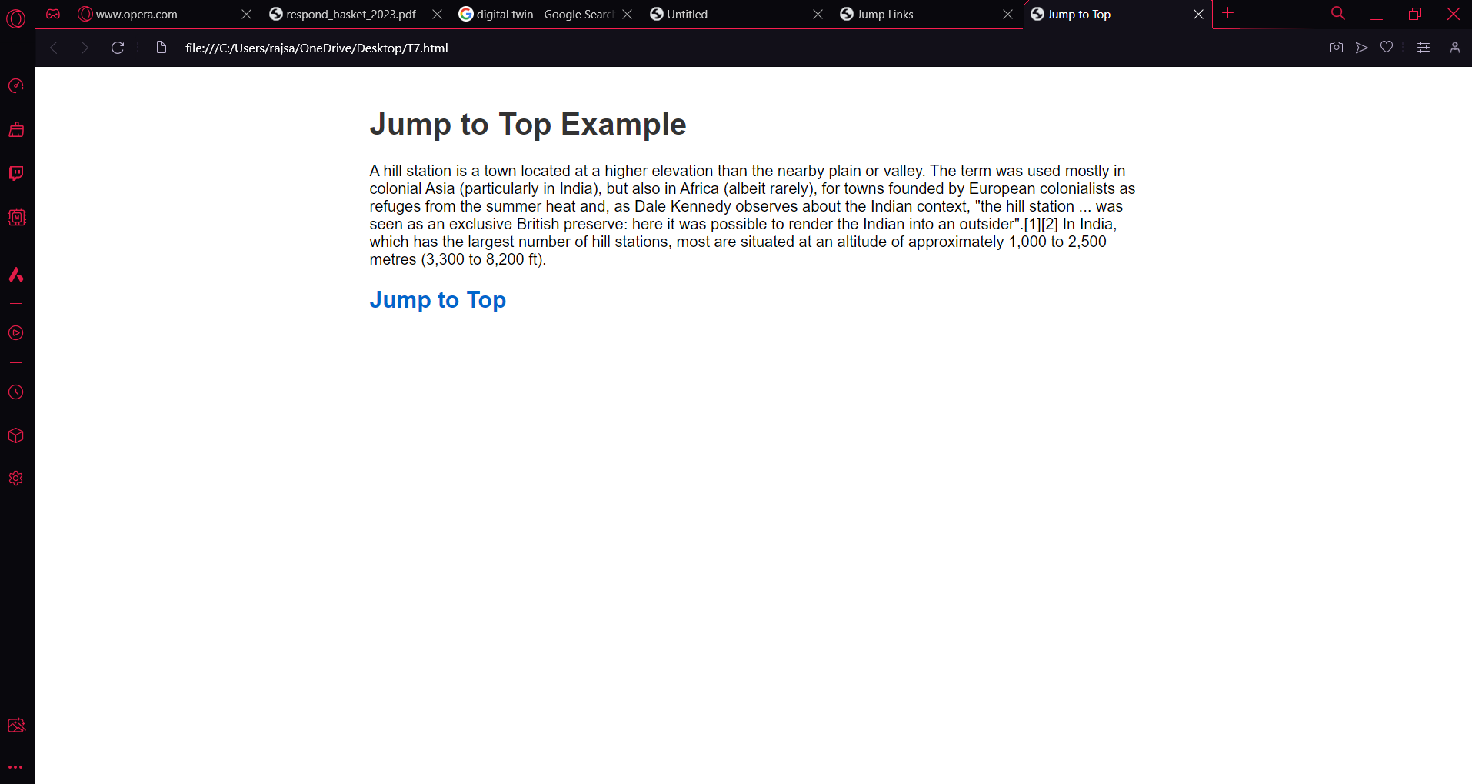

T6

<!DOCTYPE html>

<html lang="en">

<head>

<meta charset="UTF-8">

<meta name="viewport" content="width=device-width, initial-scale=1.0">

<title>Favorite Websites</title>

<style>

body {

font-family: Arial, sans-serif;

max-width: 800px;

margin: 0 auto;

padding: 20px;

}

h1, h2 {

color: #333;

}

ul {

list-style-type: none;

padding: 0;

}

li {

margin-bottom: 10px;

}

a {

color: #0066cc;

text-decoration: none;

}

a:hover {

text-decoration: underline;

}

</style>

</head>

<body>

<header>

<h1>My Favorite Websites</h1>

</header>

<section>

<ul>

<li><a href="https://www.wikipedia.com" target="_blank">Favorite Website 1</a></li>

<li><a href="https://www.instagram.com" target="_blank">Favorite Website 2</a></li>

<li><a href="https://www.youtube.com" target="_blank">Favorite Website 3</a></li>

<li><a href="https://www.chatgpt.com" target="_blank">Favorite Website 4</a></li>

</ul>

</section>

</body>

</html>

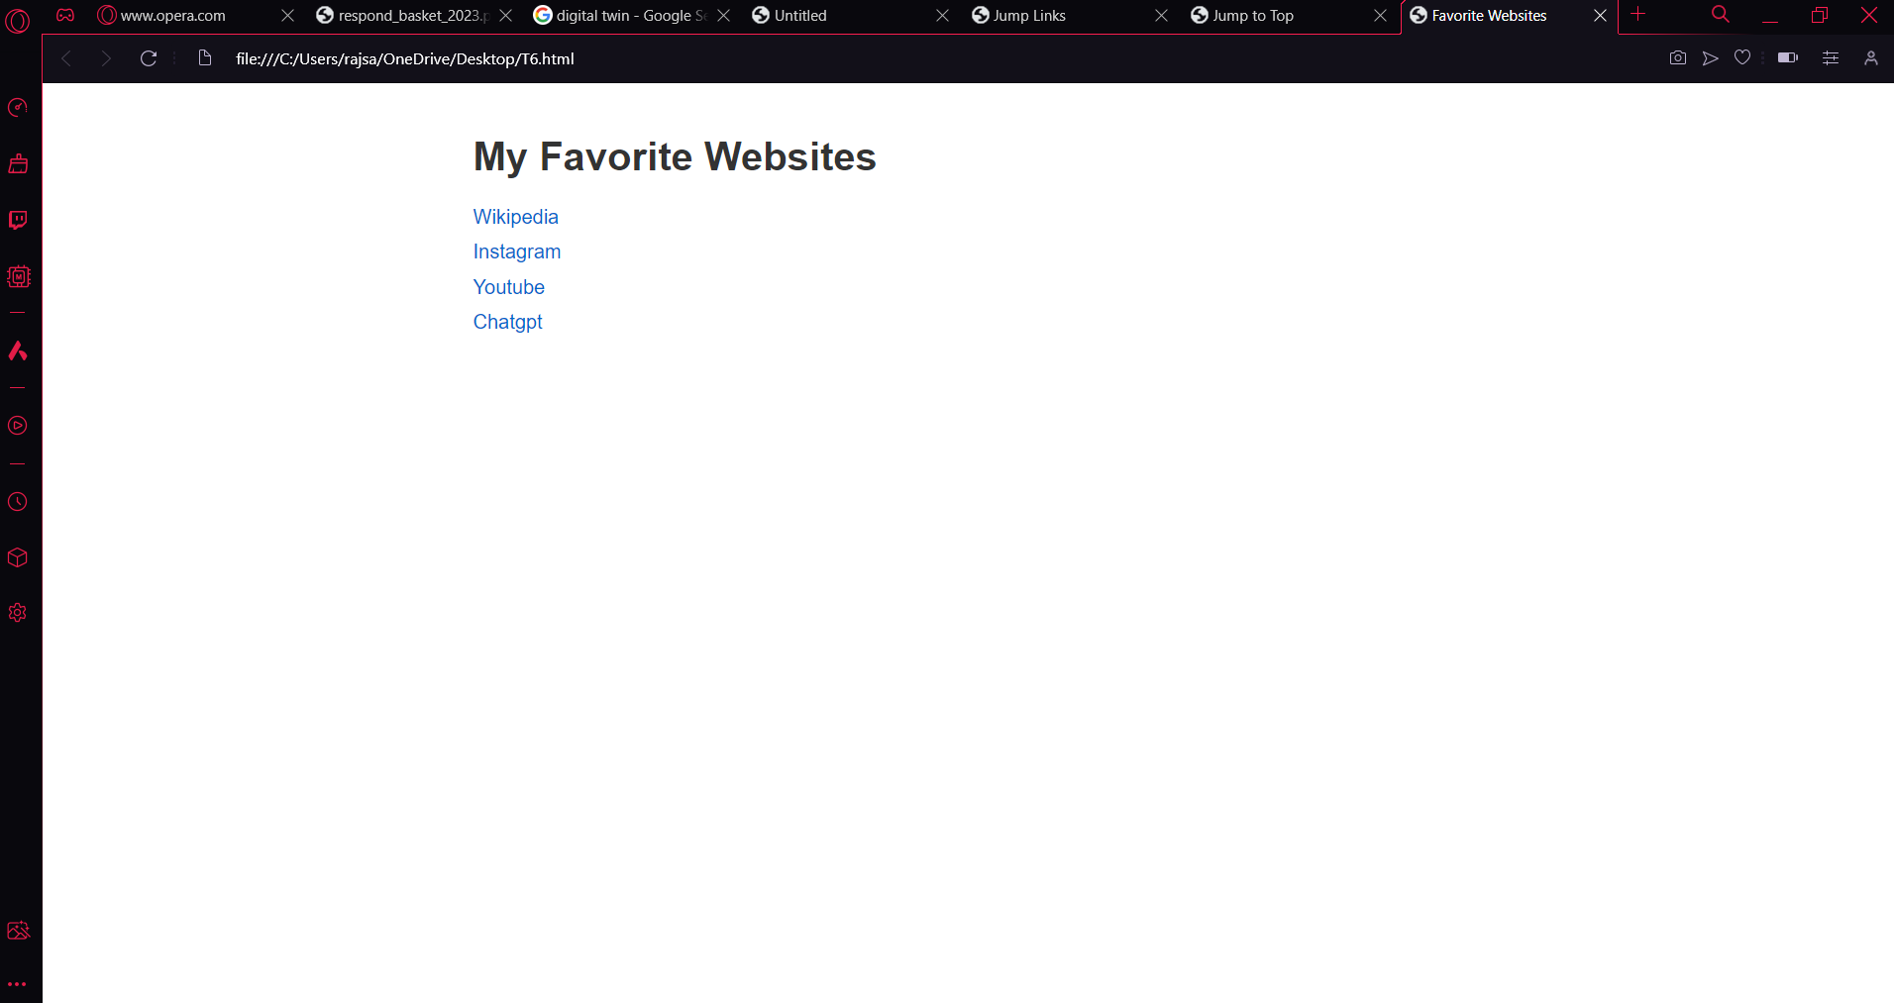

T3

<!DOCTYPE html>

<html lang="en">

<head>

<meta charset="UTF-8">

<meta name="viewport" content="width=device-width, initial-scale=1.0">

<title>Countries and Languages</title>

<style>

body {

font-family: Arial, sans-serif;

max-width: 800px;

margin: 0 auto;

padding: 20px;

}

h1, h2 {

color: #333;

}

ol {

list-style-type: upper-roman;

padding-left: 20px;

}

ol ol {

list-style-type: lower-roman;

padding-left: 20px;

}

</style>

</head>

<body>

<header>

<h1>Countries and Languages</h1>

</header>

<section>

<ol>

<li>

<h2>INDIA</h2>

<ol>

<li>Hindi</li>

<li>Marathi</li>

</ol>

</li>

<li>

<h2>JAPAN</h2>

<ol>

<li>Japanese</li>

<li>English</li>

</ol>

</li>

<li>

<h2>Brazil</h2>

<ol>

<li>Latin</li>

<li>Spanish</li>

</ol>

</li>

</ol>

</section>

</body>

</html>

Output

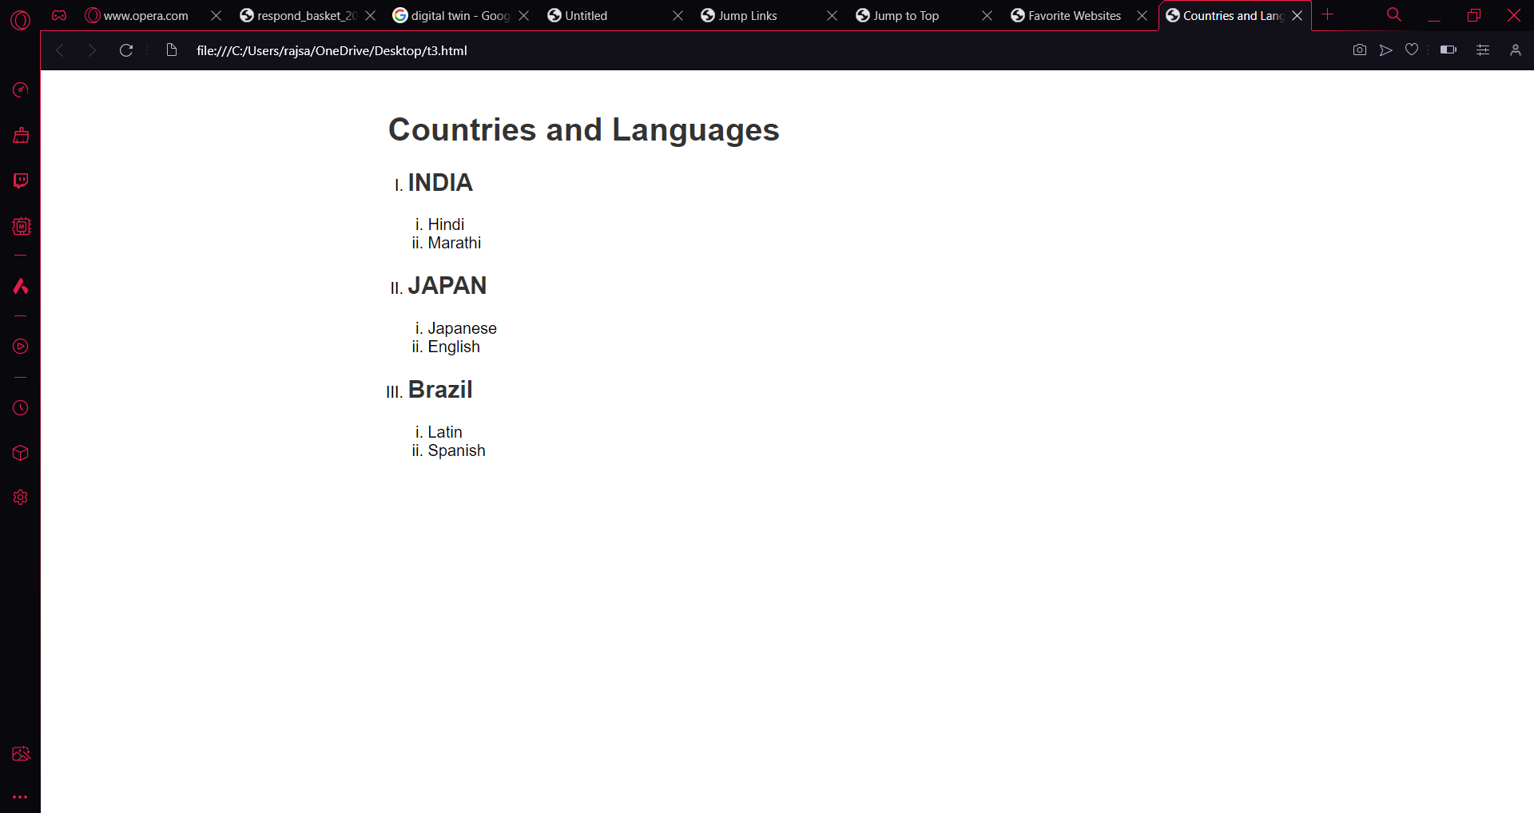

T4

<!DOCTYPE html>

<html lang="en">

<head>

<meta charset="UTF-8">

<meta name="viewport" content="width=device-width, initial-scale=1.0">

<title>Countries and Capitals</title>

<style>

body {

font-family: Arial, sans-serif;

max-width: 800px;

margin: 0 auto;

padding: 20px;

}

h1 {

color: #333;

}

table {

width: 100%;

border-collapse: collapse;

}

th, td {

border: 1px solid #ddd;

padding: 10px;

text-align: left;

}

th {

background-color: #f2f2f2;

}

</style>

</head>

<body>

<header>

<h1>Countries and Capitals</h1>

</header>

<section>

<table>

<tr>

<th>Country</th>

<th>Capital</th>

</tr>

<tr>

<td>

<ul>

<li>India</li>

<li>United Kingdom</li>

<li>Germany</li>

<li>Japan</li>

<li>France</li>

</ul>

</td>

<td>

<ol>

<li>New Delhi</li>

<li>London</li>

<li>Berlin</li>

<li>Tokyo</li>

<li>Paris</li>

</ol>

</td>

</tr>

</table>

</section>

</body>

</html>

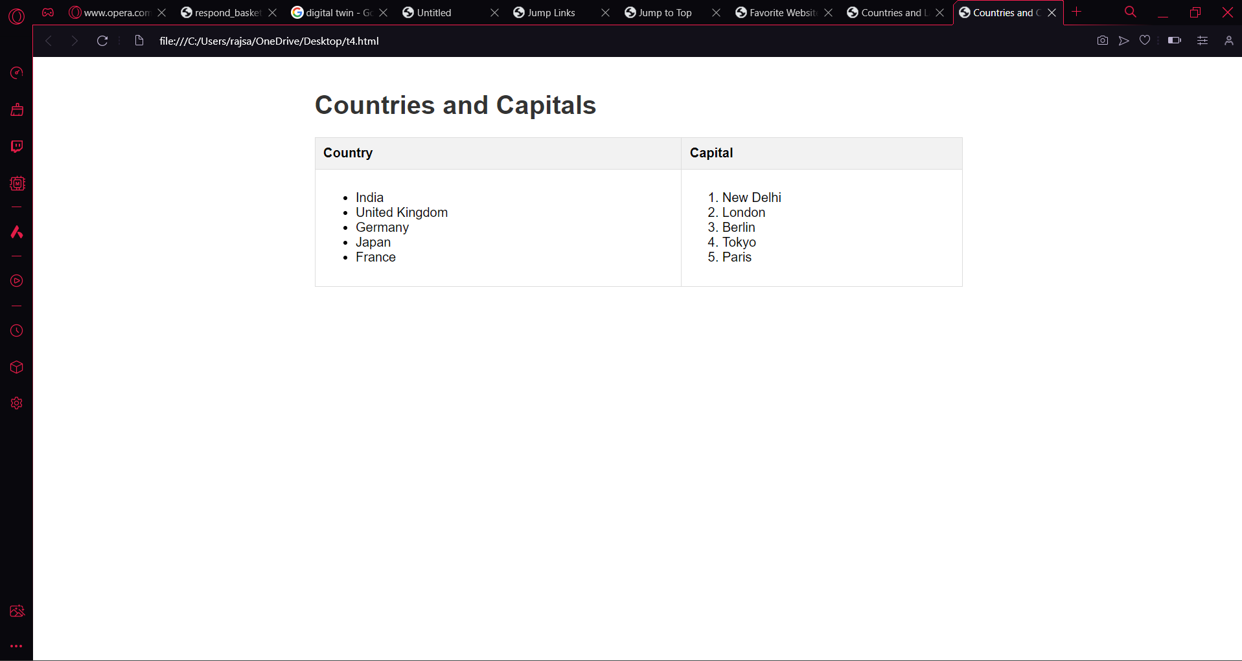

T5

<!DOCTYPE html>

<html lang="en">

<head>

<meta charset="UTF-8">

<meta name="viewport" content="width=device-width, initial-scale=1.0">

<title>Country Politicians</title>

<style>

body {

font-family: Arial, sans-serif;

max-width: 800px;

margin: 0 auto;

padding: 20px;

}

h1 {

color: #333;

}

table {

width: 100%;

border-collapse: collapse;

margin-top: 20px;

}

th, td {

border: 1px solid #ddd;

padding: 10px;

text-align: left;

}

th {

background-color: #f2f2f2;

}

</style>

</head>

<body>

<header>

<h1>Country Politicians</h1>

</header>

<section>

<table>

<tr>

<th>Country</th>

<th>Politicians</th>

</tr>

<tr>

<td>Turkmenistan</td>

<td>

<p>President Gurbanguly Berdimuhamedow</p>

<p>Vice-President Raşit Meredow</p>

</td>

</tr>

<tr>

<td>Eritrea</td>

<td>

<p>President Isaias Afwerki</p>

<p>Vice-President None</p>

</td>

</tr>

</table>

</section>

</body>

</html>

